IMAYAM COLLEGE OF ENGINEERING

DEPARTMENT OF EEE

ALUMNI DETAILS

1.About Alumni
The Alumni Association of ICE was formed to bring the old students under the Forum for dissemination and exchange of information regarding their experience, knowledge and talents amongst its members and current students of the College and to conduct seminars, conferences, meetings of engineers of all faculties for the purpose of exchange and enhancement of knowledge. A number of Alumni are placed in good positions and the college is geared to fulfilling the objective of preparing the students for various coveted and challenging positions to meet our former President Dr. A.P.J. Abdul Kalam`s Dream of 2020. Alumni Coordinators of the concerned departments play a significant role in registering and organizing the Alumni day to be a grand success

2.Success Stories/Events
- Announcement
- Invitation
- Registration Link
- Gallery
- Thanks
3.Alumni Interactions
- Announcement
- Invitation
- Registration Link
- Gallery
- Thanks

STAFF INCHARGE PRINCIPAL

Department of EEE
1.NAVEENKUMAR T
Batch:2018-22

Woosu Automotive India Private Limited
Quality Engineer

2. CHRISTOPHER J  Batch:2018-22  Woosu Automotive India Private Limited  Quality Engineer | 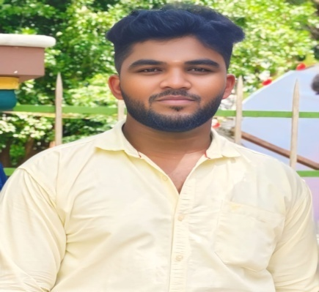
3. KAVIYARSAN N
Batch:2018-22

Japers Engineering and Automotive Service- Embedded Developer

4. SAKTHI N
Batch:2018-22

PegatronPvt.India
FAE Engineer

5. R.SATHISH KUMAR  Batch:2020-24  Nifco south Indiya manufacturing pvt.Ltd | 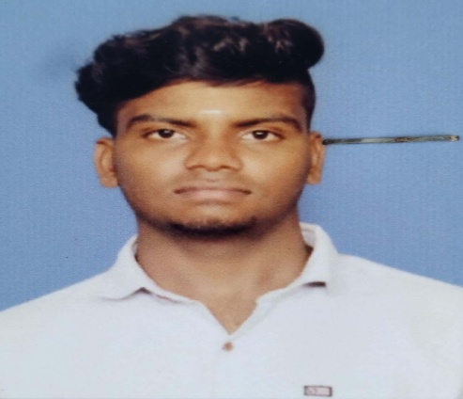
6. Renuka S
Batch:2018-22

GBrit Software Solutions
Chennai
7.Deepa Dharshini
Batch:2019-23

Hindustan Aeronautics Private Ltd
Bangalore
7.Rakesh S  Batch:2019-23  Fortune Capital Service pvt ltd | 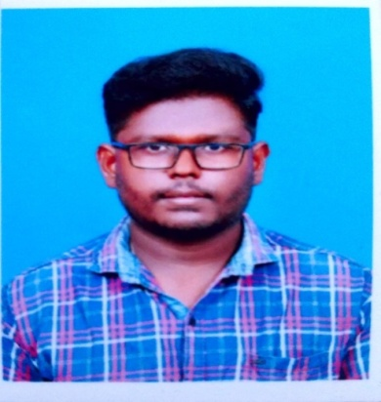
8.D.Gayathri  Batch:2020-24  Rane Brake Lining Limited  Trichy | 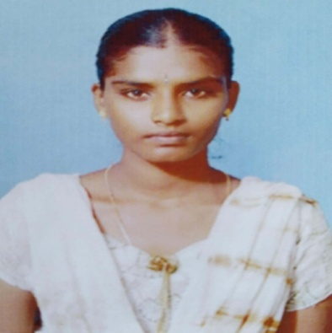
9.P.Vahini
Batch:2020-24

Zahnradfabrik Friedrichshafen India Pvt Ltd
Chennai

10.P.Kirthiga  Batch:2016-20  Yamaha Music Private Ltd,Chennai | 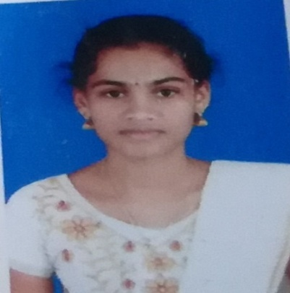
11.V.Deepan  Batch:2019-23  GBrit Software Solutions | 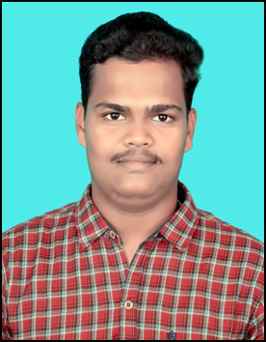
12.J.Vignesh  Batch:2017-21  Agnice Fire Protection Private Limited  Project Engineer | 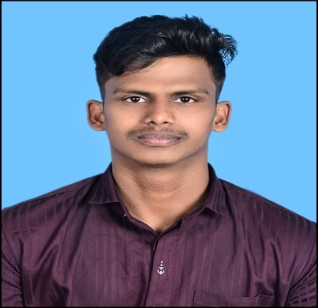

Department of ECE

Sl.No | NAME | DESIGNATION/ORGANISATION NAME | PHOTO
1 | REVATHI S  (2017-2021) | PCB DESIGN ENGINEER,  CALIBER INTERCONNECTS PVT LTD,COIMBATORE | 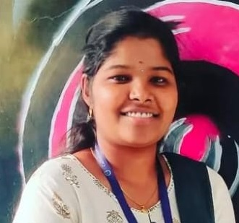
2 | ARAVINTH S  (2017-2021) | PACKAGE DESIGNER,  CALIBER INTERCONNECTS PVT LTD,COIMBATORE | 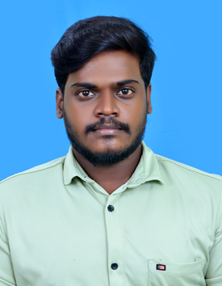
3 | PONHARIHARAN K  (2017-2021) | PACKAGE DESIGNER,  CALIBER INTERCONNECTS PVT LTD,COIMBATORE | 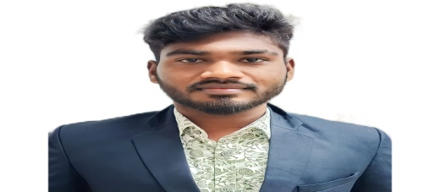
4 | KRISHNAVENI S  (2017-2021) | SOFTWARE ENGINEER  TATA CONSULTANCY SERVICES,CHENNAI | 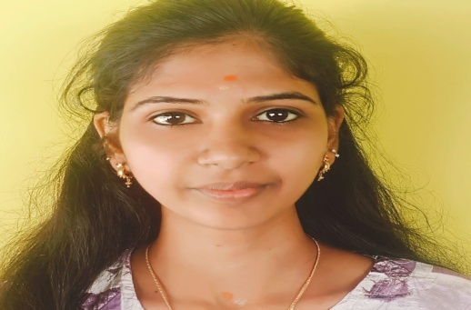
5 | B.PRIYADHARSHINI  (2015-2019) | SUBCOURT,MUSIRI  SENIOR BAILIFF | 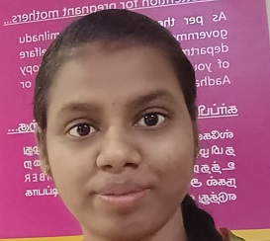
6 | A.BABYSHALINI  (2016-2020) | TECHNICIAN,  FOXCONN HON HOI TECHNOLOGY INDIA MEGA DEVELOPMENT PVT LTD,CHENNAI | 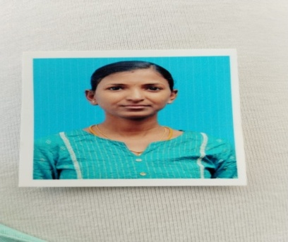
7 | DURGA A  (2017-2021) | INDUSTRIAL ENGINEER  FOXCONN HON HOI TECHNOLOGY INDIA MEGA DEVELOPMENT PVT LTD,CHENNAI | 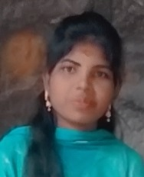
8 | ANANDHI.G  (2016-2020) | TECHNICIAN,  FOXCONN HON HOI TECHNOLOGY INDIA MEGA DEVELOPMENT PVT LTD,CHENNAI | 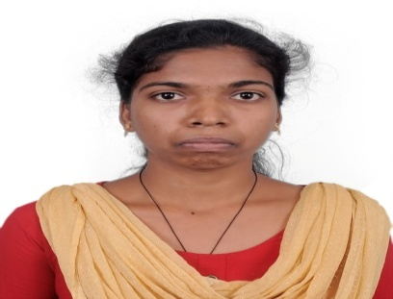
9 | AJITHKUMAR S  (2017-2021) | MACHINE OPERATOR  TENNECO AUTOMOTIVE INDIA PVT LTD,HOSUR | 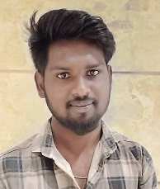
10 | VIJAY R  (2017-2021) | MACHINE OPERATOR  TENNECO AUTOMOTIVE INDIA PVT LTD,HOSUR | 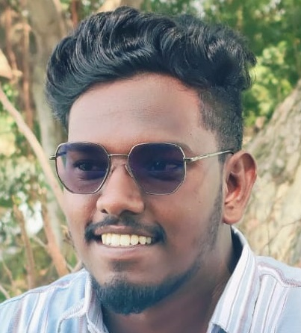

Department of Mechanical Engineering

1.NAVEEN PRASANTH  WOOSU AUTOMOTIVE INDIA PRIVATE LIMITED  BATCH:2018-22 | 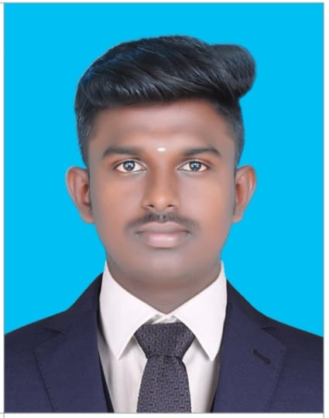
2. DINESH P  Ashok Leyland Ltd , Hosur  BATCH:2018-22 | 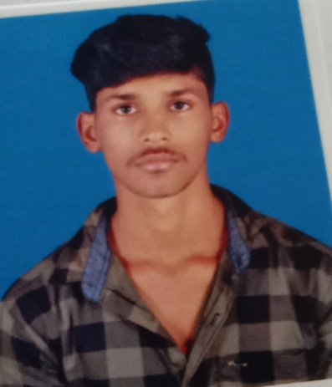
3. MADHAVAN M  KIN Railway equipment pvt Ltd  BATCH:2020-24 | 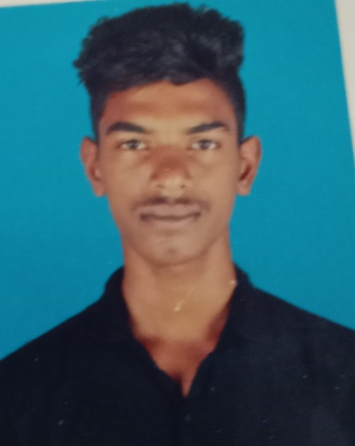
4. KISHORKUMAR R  Rathna techno solutions  BATCH:2018-22 | 
5.MANIKANDAN M  Ashok Leyland Ltd , Hosur  BATCH:2020-24 | 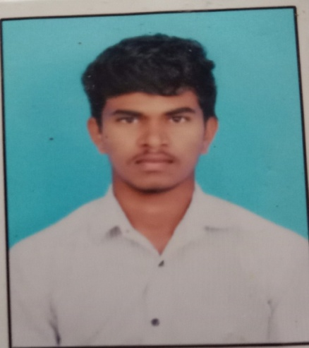
6. JEGANATH D R  Ashok Leyland Ltd , Hosur  BATCH:2020-24 | 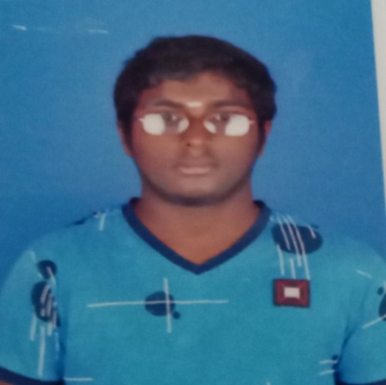
7.MANIKANDAN K  Ashok Leyland Ltd , Hosur  BATCH:2020-24 | 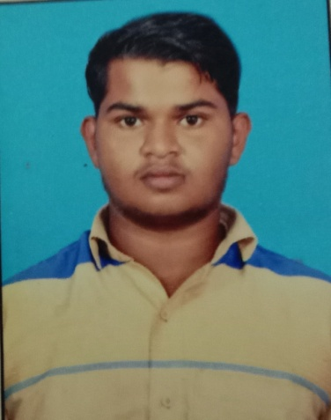
8. MANISHWARAN P  Ashok Leyland Ltd , Hosur  BATCH:2019-23 | 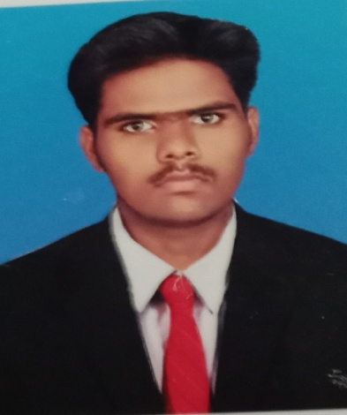
9. PRAVEEN P  Ashok Leyland Ltd , Hosur  BATCH:2019-23 | 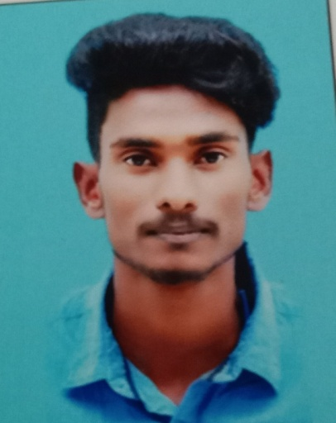
10.PREMRAJ S  BATCH:2019-23  Ashok Leyland Ltd , Hosur | 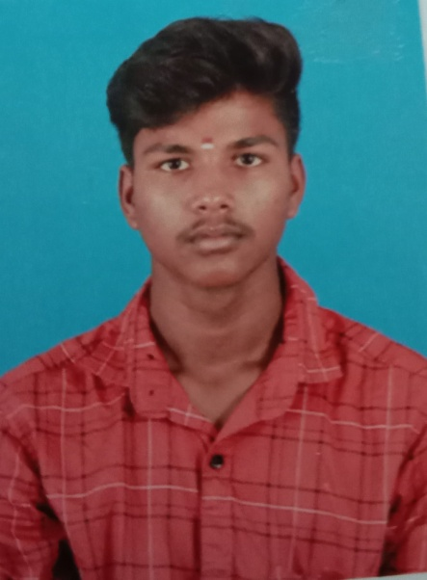
11. KARTHIKEYAN D  BATCH:2019-23  Ashok Leyland Ltd , Hosur | 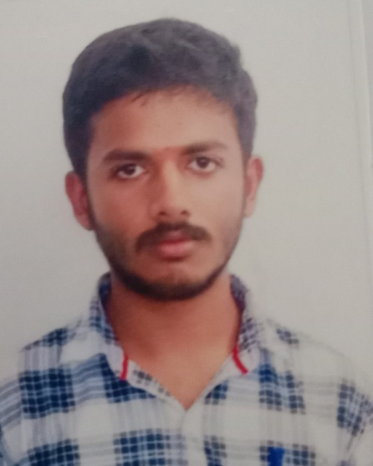
12. VIGNESH K  Mudhra fine blanc pvt Lit  BATCH:2019-23 | 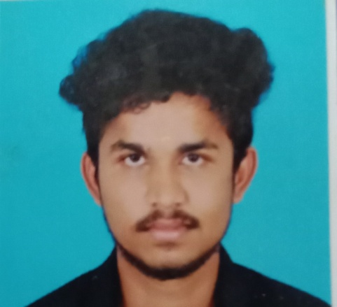

Department of CSE

Name | YEAR | Department | Destination | Company Name | Photo
Dineshwaran A | 2019-2023 | CSE | Software Engineering | Synergy Marine Group, Chennai | 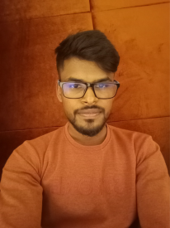
Thirumal R | 2019-2023 | CSE | Network Associate Engineer | Interlock Solution, Pudukkottai | 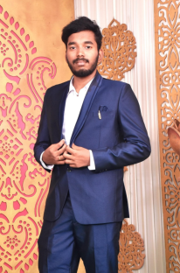
Vasanth R | 2019-2023 | CSE | UI&UX DESIGNER | Finfortune Financial Services Pvt Ltd, Chennai | 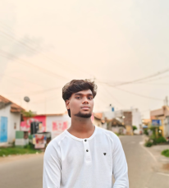
Raja V | 2019-2023 | CSE | Technical support Engineer | Inspirisys Solution Limited, Salem | 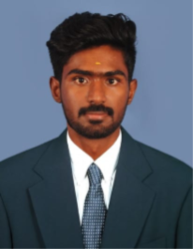
Nithya G | 2015-2019 | CSE | Technical support engineer | Corent technology, Chennai | 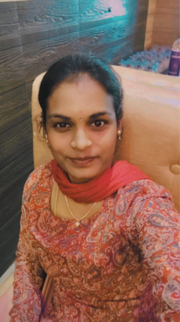
sandhiya R | 2015-2019 | CSE | Team Leader | Olympic Financial services,Chennai | 
Kirubakaran P | 2015-2019 | CSE | Executive Manager | AXIS BANK,Trichy | 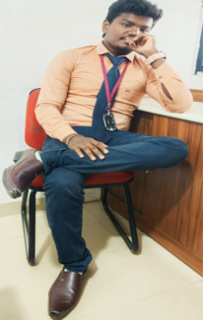
Archana A | 2015-2019 | CSE | Assistant Programmer  (Public Elections Department) | The Zigma Technologies India (P) Limited  (District Collectorate),Perambalur | 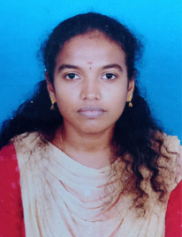
Sumathi U | 2015-2019 | CSE | Software Engineer | syncfusion software private limited ,Chennai | 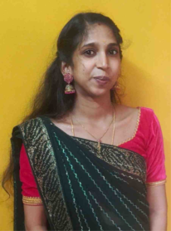
Satheesh Kumar K | 2015-2019 | CSE | Software Engineer | XmindsInfotech,Kerala | 